# Title Page

**Plant community compositional stability over 40 years in a Fraser River Estuary tidal freshwater marsh**

Stefanie L. Lane1, Nancy Shackelford2, Gary E. Bradfield3, Madlen Denoth3, 4, Tara G. Martin1

1Conservation Decisions Lab, Department of Forest and Conservation Science, University of British Columbia, Vancouver, BC, Canada; 2School of Environmental Studies, University of Victoria, Victoria, BC, Canada; 3Department of Botany, University of British Columbia, Vancouver, BC, Canada; 4Gymnasium Neufeld, Bern, Switzerland

Corresponding author: [stefanielane@utexas.edu](mailto:stefanielane@utexas.edu)

ORCID ID

Stefanie L. Lane (corresponding author): [0000-0002-4851-2772](https://orcid.org/0000-0002-4851-2772)

Nancy Shackelford: [0000-0003-4817-0423](https://orcid.org/0000-0003-4817-0423)

Tara G. Marin: [0000-0001-7165-9812](https://orcid.org/0000-0001-7165-9812)

## Acknowledgements

We are grateful to Z. Davis for providing R programming advice, and P. Roper for 2019 field assistance. B. Staines (Ladner Harbour Authority) provided canoe and harbor access for all field navigation. Research site access was granted by The Ministry of Forests, Lands, Natural Resource Operations and Rural Development.

# Abstract

*Wetlands: Please provide an abstract of 150 to 250 words. The abstract should not contain any undefined abbreviations or unspecified references.*

Long-term data sets documenting temporal changes in vegetation communities are uncommon, yet imperative for understanding trends and triggering potential conservation management interventions. For example, decreasing species diversity and increasing exotic species abundance may be indicative of decreasing community stability. We explore long-term plant community change over a 40-year period through the contribution of data collected in 2019 to two historical datasets collected in 1979 and 1999 to evaluate decadal changes in plant community biodiversity in a tidal freshwater marsh in the Fraser River Estuary in British Columbia, Canada. We examine whether characteristic plant assemblages are consistent over time, whether alpha (α) and beta (β) diversity change within and between assemblages, and whether associated indicator species change. We found that while plant assemblages were characterized by the same dominant indicator species while most other indicator species changed, and that α-diversity decreased while β-diversity increased. Further, we found evidence for plant assemblage homogenization through the increased abundance of exotic species. These observations may inform concepts of habitat stability in the absence of pulse disturbance pressures, and corroborate globally observed trends of native species loss and exotic species encroachment. Our results indicate that within the Fraser River Estuary, active threat management may be necessary in areas of conservation concern in order to prevent further native species biodiversity loss.

# Keywords

*Wetlands: four to six*

shifting baselines; reference conditions; dispersal networks; species turnover; conservation land management

# Introduction

In a time of rapid global change, temporal shifts in plant community composition can indicate ecosystem stress response and inform conservation management interventions. Shifts in community-dominant species, loss of native species diversity, and increasing abundance of exotic species may indicate loss of stability through loss of species or functional redundancy (Donohue et al., 2016; Holling, 1973). In turn, this may indicate reduced resistance to change or capacity to recover from disturbance, known as resilience (Bai, et al., 2004; Tilman, Reich, & Knops, 2006). Furthermore, the local loss of native species may have stronger negative impacts on regional biodiversity persistence when the regional pool of potential species is reduced or environmentally constrained (Hanski, 1982; Lepš, 2004). Characterization of plant community changes on decadal timescales contributes to observation of meaningful long-term patterns of compositional stability, and is instructive for developing hypotheses to test drivers of disturbance, especially in dynamic landscapes heavily impacted by anthropogenic activities such as estuaries (Ovaskainen et al., 2019; Underwood et al., 2000).

Estuaries are at the terrestrial-marine interface where hydrogeomorphic and ecological changes occur on annual, decadal, and millennial timescales (Pasternack, 2009). Estuarine habitats support high species richness, including species at risk (Kehoe et al., 2021) and are important carbon reservoirs (Douglas, et al., 2022). Because these ecosystems will experience accelerated change under sea level rise, they are of increasing conservation concern (Brophy et al., 2019); understanding estuarine habitat stability can inform global change resilience strategies. Estuaries in North America are of particular conservation importance in the Pacific Northwest (PNW) because their pathways of retreat or expansion are often spatially restricted by fjord geography (Emmett et al., 2000), whereas estuaries along the Atlantic coast may spread along expansive coastal plains. Tidal freshwater marshes are the upper reaches of estuaries dominated by riverine freshwater, and in the PNW they are particularly important as early transitional habitat along a salinity gradient for anadromous salmonids (Chalifour et al., 2019; Davis et al., 2021). Within the Fraser River Estuary 85% of floodplain and 64% of stream habitat has been lost (Finn et al., 2021), emphasizing the need to understand the condition of remaining estuarine habitat. Estuary conservation efforts are intended to protect coastal municipalities and provide sufficient habitat for wildlife, and stability of plant communities within tidal marshes contribute to the ability of these habitats to resist change or recover from disturbance (Holling, 1973).

A challenge of understanding community stability, including within estuaries, is the lack of long-term data. In the absence of long-term monitoring, historical datasets can provide a ‘snapshot’ of species compositional variation over time. One such opportunity exists in the Fraser River estuary, British Columbia, Canada in an area called Ladner Marsh (Figure 1). Despite large-scale industrialization and urbanization within the region, Ladner Marsh has escaped development, and to the best of our knowledge has not experienced major natural or anthropogenic disturbance in the past 50 years. Two historical studies conducted at Ladner Marsh (Bradfield & Porter, 1982; Denoth & Myers, 2007) used similar methods to document floristic diversity. While these studies independently characterize different community metrics, these datasets provide the opportunity to repeat observations and characterize long-term plant community changes and habitat stability. We used three observational datasets spanning four decades to answer the following questions:

1. Are tidal freshwater marsh assemblages characterized by the same dominant plant species over a 40-year period? In the absence of significant environmental disturbance, we expect the same species composition to dominate each assemblage as identified by Bradfield & Porter (1982).
2. Are assemblages characterized by similar indicator plant species? If not, which species gained or lost are driving changes within each assemblage? We expect that increasing abundance of invasive species over time would result in greater net number of native species lost (and fewer net native species gained).
3. Is the mean species diversity (α-diversity) and variation (β-diversity) within and across assemblages constant between the three sampling periods (1979, 1999, 2019)? If the plant community is stable, we expect little change in α-diversity and β-diversity.

# Methods

## Physical & ecological context

The Fraser River is the largest catchment in British Columbia, covering one quarter of the province. The estuary currently spans 2,814 ha, one-third of which lies within the South Arm Marshes Wildlife Management Area (Schaefer, 2004) (Figure 1B). Ladner Marsh occupies approximately 100 ha within the South Arm Marshes, bounded to the east by urban and industrial development and to the west by the Fraser River (Figure 1C).

Plant species common to these habitats are generally herbaceous, and the community is largely dominated by sedges and rushes with some salinity tolerance, but a greater diversity of herbaceous flowering species (hereafter, forbs). Forb species such as bogbean (*Menyanthes trifoliata* L.) are tolerant of continuously waterlogged conditions, whereas sedges (*Carex lyngbyei* Hornem.) are better adapted to microsites that are regularly inundated and drained (Bradfield & Porter, 1982). Grass species such as non-native tall fescue (*Festuca arundinaceae* Schreb.) may prefer the most well-drained sites, although some non-native species such as reed canary grass (*Phalaris arundinaceae* L.) tolerate more saturated soils, and present an invasion threat in tidal wetlands (Sinks et al., 2021).

At Ladner Marsh, Bradfield & Porter (1982) identified three distinct community sub-types (hereafter, “assemblages”). Denoth & Myers (2007) repeated the sampling to determine whether an exotic species was displacing a listed species of conservation concern in British Columbia, Henderson’s checker-mallow (*Sidalcea hendersonii* S. Watson). Henderson’s checker-mallow is locally abundant in this marsh, and thus stability of sufficient habitat is vital for its conservation.

## Vegetation surveys

### 1979 and 1999

The first data collection was conducted in 1979 (Bradfield & Porter, 1982). Eight transects were positioned along a north-to-south gradient, and 1 m2 quadrats (plots) were placed in the center of vegetation patches where species composition noticeably changed, or every 10 m along the transect, whichever distance was shorter (Bradfield, 2019 personal comm.) (Figure 1D). Cluster analysis and principal components analysis (PCA) distinguished three main plant assemblages, each dominated by a distinct species: Sedge (*Carex lyngbyei*), Fescue (*Festuca arundinaceae*), and Bogbean (*Menyanthes trifoliata*). Bradfield & Porter (1982) hypothesized that edaphic factors drove assemblages, such as waterlogged soils in the bogbean assemblage, or drainage along channel edges in the fescue assemblage.

A subsequent survey conducted in 1999 recreated the transects and sought to place sampling plots at the exact positions sampled in 1979 to test relationships between invasive purple loosestrife (*Lythrum salicaria*, L.) and Henderson’s checker-mallow (*Sidalcea hendersonii*) (Denoth & Myers, 2007). While Denoth & Myers did not seek to test changes in community composition, data were collected according to the same protocols as in 1979, and the data have been made available for comparison. This publication will reference dates the data were collected, rather than publication dates of the corresponding studies.

### 2019

As no permanent markers were left in Ladner Marsh, the precise locations of transects assessed by Bradfield & Porter (1982) or (and?) Denoth & Myers (2007) were not identifiable in 2019. Transect endpoints were approximated within ~5 m by overlaying Figure 1 in Bradfield & Porter’s 1982 publication (Figure 1D) on a georeferenced basemap, aligning prominent features such as tidal channel tributary junctions, and marking GPS locations in Avenza Maps (Avenza Systems Inc., Ontario, Canada, v. 3.2). Transect “Q” (n = 7 plots) was omitted in 1999 and 2019 due to inaccessibility through riparian forest with a dense understory of Himalayan blackberry (*Rubus armeniacus* Focke); these plots from 1979 are not included in the present analyses. An additional 18 plots surveyed in 1979 and 1999 also were omitted in 2019 because of overgrowth of riparian fringe, widening of tidal channels, or variation in transect placement (Figure 1, Table 3). Despite these decisions to exclude plots, Kopecký & Macek (2015) have demonstrated that uncertainty of plot location does not produce unreliable evidence of plant community changes on decadal timescales.

Vegetation was sampled in a similar manner as in the 1979 survey by semi-systematically placing 1 m2 quadrats (plots) in the center of patches where species composition noticeably changed, or at 10 m intervals along transects, whichever distance was shorter (Figure 1E). Individuals were defined as “in the plot” if > 50% of their basal cover occurred within the quadrat boundary; overhanging stems that originated outside the plot were not included Aerial cover was estimated by modified Braun-Blanquet cover classes [0 = (0%), 1 = (< 25%), 2 = (25-50%), 3 = (50-75%), and 4 = (> 75%)].

### Taxonomy

Observation of vascular plant species was conducted in all sampling years during early summer (approx. June-July). In all datasets, most plants were identified to species according to Hitchcock & Cronquist (1973), although a few were identified at higher taxonomic levels due to insufficient identifying characteristics (n = 6 to genus, n = 2 to Family; see Table 7). To account for changes in nomenclature revision over time, all datasets were harmonized to use the most recently accepted species name as reported in the PLANTS Database of the United States Department of Agriculture, Natural Resources Conservation Science [USDA NRCS]. For example, in the instance of *Agrostis* species, we assumed *Agrostis alba* L. identified in 1979 and 1999 was synonymous with *Agrostis stolonifera* L. in 2019. All species and their synonymous nomenclature from prior data collection years are available in Supplemental (Table 8).

## Analyses

To examine changes in marsh vegetation assemblages over time, cluster analysis was performed for each observation year using Euclidean distance as the measure of plot dissimilarity (“stats,” R Core Team). We also used Bray-Curtis distance which accounts for species identity and is less sensitive to species absence (Legendre & Legendre, 2012); however, as both distance measures produced similar results, we present only the Euclidean distance results here to facilitate direct comparisons to results in Bradfield & Porter (1982). Clusters were cut into three groups (“assemblages”), and species indicator analysis was used to determine the main characterisitc species for each group(“indicspecies,”R package De Cáceres & Jansen, 2016). Indicator Value (IndVal) association indices between species and groups were calculated using an abundance-based point biserial correlation coefficient (multipatt func = “r.g”); significance of associations was tested by permutational analysis (Dufrêne & Legendre, 1997). Table 7.

Community diversity calculations followed Whittaker (1975), with α-diversity calculated as the mean number of species per quadrat within an observation year and assemblage, and β-diversity calculated as the total number of species within the assemblage divided by α-diversity. These calculations were also performed on all data recorded for the observation year to generate a community-wide measure of vegetation diversity. Community turnover for each assemblage was measured using the “codyn” R package (Hallett et al., 2016). Total species turnover (total magnitude of change), species gained (appearances), and species lost (disappearances) were calculated as a percent change for each assemblage between 1979-1999, and 1999-2019. Total turnover was calculated as a ratio of the absolute value of species gained and lost to the total number of species observed in both timepoints.

During analyses, both Euclidean and Bray-Curtis distances were used to assess the effect of distance measure on results. To address inconsistent numbers of plots grouped into assemblages each year, diversity metrics were bootstrapped 10 times using the minimum number of plots observed in an assemblage each year (n = 18) (Table 5). All analyses were performed in R v.4.0.2 (cite the R team).

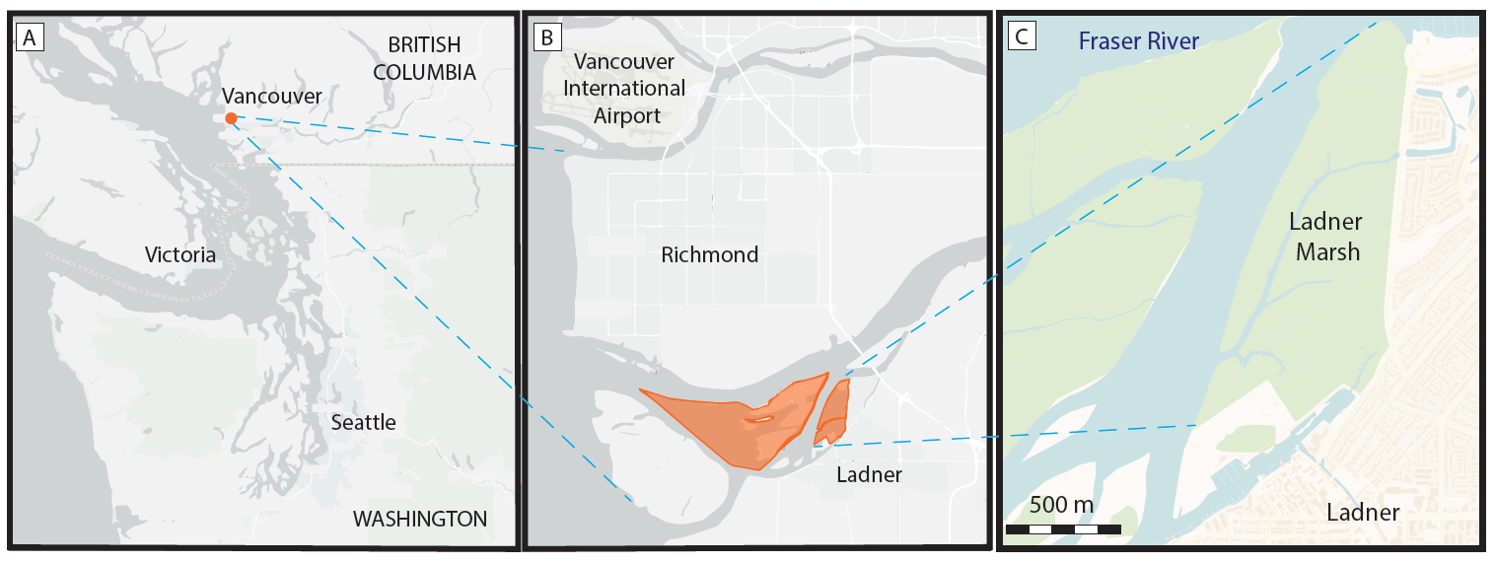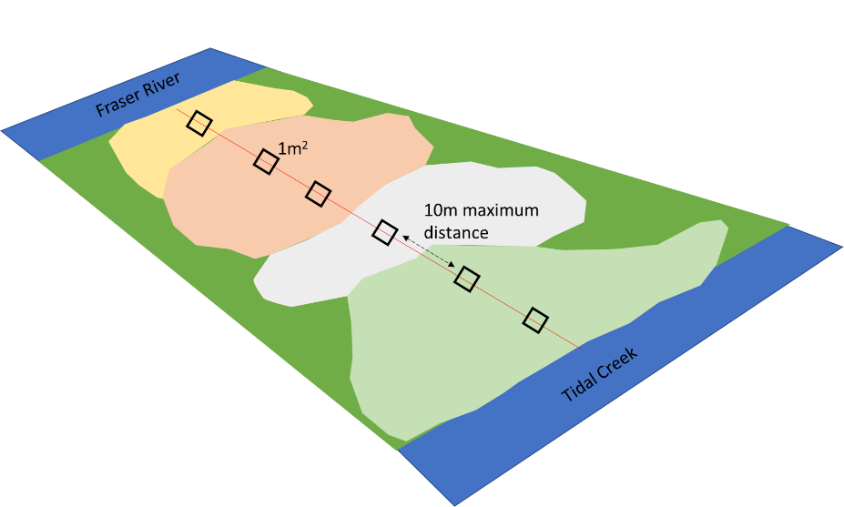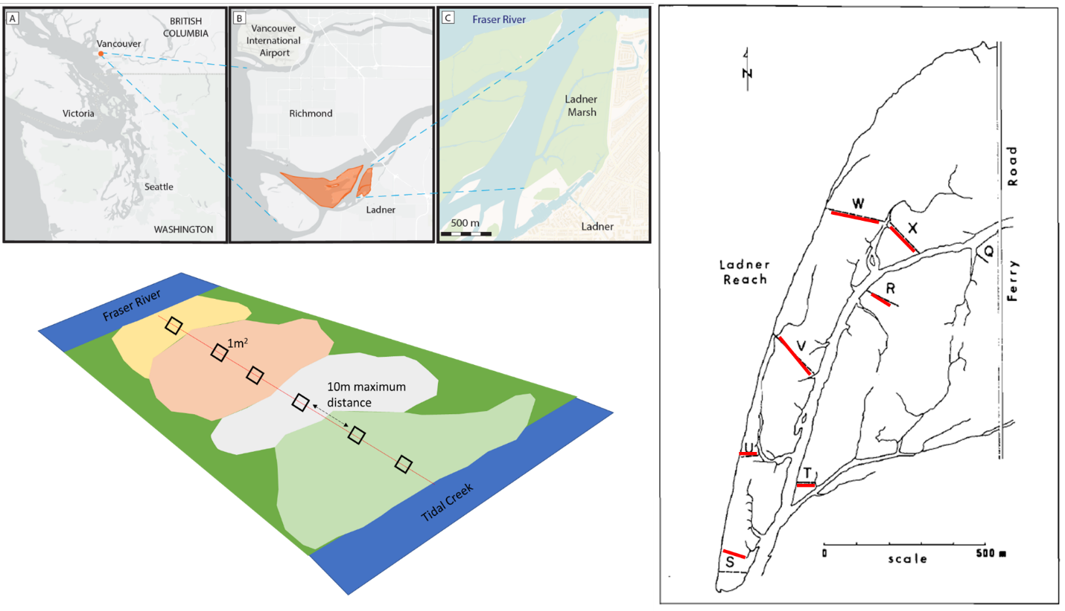

D

E

Figure .Study area location and sampling design. (A) Regional location of the Fraser River Estuary in southwestern British Columbia, Canada, (B) South Arm Marshes Wildlife Management Area (highlighted in orange), (C) Ladner Marsh abuts municipal development on the south bank of the Fraser River. (D) overlay of 2019 transect locations (shown in red) on original transect map from Bradfield and Porter (1982), and (E) illustration of semi-systematic plot placement along transect bisecting different vegetation patches.

# Results

Three main assemblages from cluster analysis, characterized by the same dominant indicator species - Sedge (*Carex lyngbyei*), Fescue (*Fescue arundinaceae*), and Bogbean (*Menyanthes trifoliata*) - were evident across all sampling periods (Fig 2). Overall dendrogram structures were similar for 1979 and 1999, but two main vegetation changes were evident in the 2019 dendrogram, notably, an increased homogenization of assemblages (i.e. shorter dendrogram branch lengths within groups and longer branch lengths between groups), and a switch from a stronger Fescue-Sedge connection in 1979 and 1999 to a stronger Fescue-Bogbean connection in 2019 (Fig. 2).

While the three assemblage indicator species remained constant over time, other species with significant indicator values changed over time (Table 2). For example, in 1979 the indicator species defining the Sedge assemblage cluster were *C. lyngbyei, Sagittaria latifolia* Wiild.*,* and *Schoenoplectus tabernaemontani* (C.C.Gmel.) Palla. In 1999, however, the same assemblage included indicator species *C. lyngbyei,* and *Impatiens capensis* Meerb. By 2019, *C. lyngbyei* was the only indicator for this assemblage. Similarly, *F. arundinaceae* remained a common indicator species within the Fescue assemblage, but the assemblage lost four out of seven total indicator species between 1979-2019. While the identities of the remaining indicator species changed, there was no strong trend of changes in clade, or potential difference for changes in ecological function based on a qualitative review of changing species identity.

Across the entire Ladner Marsh plant community, two to three species were lost each year following the 1979 survey. Within every assemblage α-diversity (mean number of species per plot) decreased every observation year, while β-diversity (ratio of total species in the assemblage to α-diversity) increased each year for all assemblages (Table 1). For example, the Sedge community suffered the least loss of species and α-diversity across sampling years, although β-diversity increased as in other assemblages, indicating increasing variability (and thus increased rarity) in which species may be encountered within a given assemblage. The Fescue assemblage had the greatest loss of α-diversity (> 50%) between 1979 and 2019. Nearly 50% fewer plots clustered as Fescue in 2019 than in 1979, however bootstrapping 18 random plots from every sampling year showed the same trend, indicating that loss of species was not related to loss of plots (Table S5). Total magnitude of species turnover between 1999 and 2019 was ~50% in each assemblage, largely driven by greater species disappearance (loss) between 1999 and 2019 (Table 6).

The greatest loss of native species richness occurred in the Fescue assemblage, while gains in exotic richness were found in all assemblages (Table 7). The Fescue assemblage had a net loss of 18 native species between 1979 and 2019. Among the species lost from the Fescue assemblage, 12 were lost from all three assemblages (six forbs, six graminoids), or were never found in any other assemblage. Species gained include two woody species, and one each of forb, graminoid, and fern ally (*Equisetum arvense* L.). There was a net zero gain of exotic species in the Fescue assemblage, however exotic *Phalaris arundinaceae* (reed canary grass) accounts for the greatest 2019 mean cover in the entire assemblage (25-50% mean cover). In the Bogbean assemblage, new exotic species include *P. arundinaceae* and *Iris pseudacorus* (yellow flag iris). Within the Sedge assemblage, there was a net loss of 3 native species, and net gain of 3 exotic species, including *P. arundinaceae* and *I. pseudacorus*. As of 2019, these species accounted for < 25% mean cover, but may be of significant management concern.

Cover abundance of species significantly defining assemblage associations show an overall trend of decreasing cover over time (Figure 3). Notably, Fescue assemblage shows ~50% decrease in cover of its exotic indicator *F. arundinaceae* between 1979 and 2019, while cover of exotic *P. arundinaceae* tripled since 1999. In the Sedge assemblage both native indicator sedge *C. lyngbyei* and exotic indicator grass *A. stolonifera* had decreased cover abundance from 1979-2019 (Figure 2, ), with each species losing ~25-35% cover abundance between 1979-2019. Meanwhile, exotic species *Lythrum salicaria* and *F. arundinaceae* increased ~50% and 100%, respectively, in abundance (< 25% mean cover) by 2019 (Table 7). Similarly, in the Bogbean assemblage, cover abundance of native species *M. trifoliata* declined ~21% (50-75% mean cover) by 2019, while cover of exotic *Mentha aquatica* L. increased ~385% (~25-50% mean cover). .

Table Between 1979 and 2019, 8 fewer plots and 5 fewer species were observed, resulting in lower α-diversity and greater β-diversity. For each assemblage type, Bogbean is the only assemblage to proportionally gain plots between 1979 and 2019, while the Fescue and Sedge assemblages lost plots. Plot loss did not appear to have an effect on diversity components, as tested by bootstrapping a minimum of 18 plots per assemblage each year (Table 5)

|  |  |  |  |  |  |  |
| --- | --- | --- | --- | --- | --- | --- |
|  | **Plot-level components** | |  | **Diversity components** | | |
| **Assemblage** | **No. quadrats** | **No. species** |  | **α diversity** | **α diversity sd** | **β diversity** |
| **Sedge** |  |  |  |  |  |  |
| 1979 | 34 | 36 |  | 8.74 | 2.45 | 3.89 |
| 1999 | 31 | 35 |  | 8.26 | 1.98 | 4.24 |
| 2019 | 28 | 34 |  | 7.89 | 2.69 | 4.31 |
|  |  |  |  |  |  |  |
| **Fescue** |  |  |  |  |  |  |
| 1979 | 29 | 47 |  | 12.83 | 3.87 | 3.66 |
| 1999 | 33 | 41 |  | 9.69 | 3.96 | 4.23 |
| 2019 | 18 | 27 |  | 5.83 | 2.79 | 4.63 |
|  |  |  |  |  |  |  |
| **Bogbean** |  |  |  |  |  |  |
| 1979 | 19 | 32 |  | 12.84 | 3.61 | 2.49 |
| 1999 | 18 | 36 |  | 11.50 | 2.92 | 3.13 |
| 2019 | 28 | 34 |  | 10.46 | 1.90 | 3.25 |
|  |  |  |  |  |  |  |
| **Total** |  |  |  |  |  |  |
| 1979 | 82 | 48 |  | 9.96 | 3.41 | 4.82 |
| 1999 | 82 | 45 |  | 9.55 | 3.30 | 4.71 |
| 2019 | 74 | 43 |  | 8.36 | 3.03 | 5.14 |

Table . Species significantly driving cluster groups (Euclidean distance) include the same dominant species in each assemblage type (Sedge by Carex lyngbyei, Fescue by Festuca arundinaceae, Bogbean by Menyanthes trifoliata). Indicator species significantly defining the assemblage reported for p < 0.05.

|  |  |  |  |  |  |  |  |  |
| --- | --- | --- | --- | --- | --- | --- | --- | --- |
|  | **1979** | |  | **1999** | |  | **2019** | |
| Cluster Group Name | Species | p-value |  | Species | p-value |  | Species | p-value |
|  |  |  |  |  |  |  |  |  |
| "Sedge" | *Carex lyngbyei* | 0.0001 |  | *Carex lyngbyei* | 0.0001 |  | *Carex lyngbyei* | 0.0001 |
| *Sagittaria latifolia* | 0.0001 |  | *Impatiens capensis* | 0.0147 |  |  |  |
| *Schoenoplectus tabernaemontani* | 0.0004 |  |  |  |  |  |  |
|  |  |  |  |  |  |  |  |  |
| "Fescue" | *Festuca arundinaceae* | 0.0001 |  | *Poa palustris* | 0.0001 |  | *Phalaris arundinaceae* | 0.0001 |
| *Salix lasiandra* | 0.0001 |  | *Festuca arundinaceae* | 0.0006 |  | *Festuca arundinaceae* | 0.0001 |
| *Equisetum palustre* | 0.0001 |  | *Trifolium wormskioldii* | 0.0014 |  | *Equisetum fluviatile* | 0.0127 |
| *Lathyrus palustris* | 0.0003 |  | *Bidens cernua* | 0.0044 |  |  |  |
| *Sidalcea hendersonii* | 0.0058 |  |  |  |  |  |  |
| *Hordeum brachyantherum* | 0.0157 |  |  |  |  |  |  |
| *Deschampsia caespitosa* | 0.0455 |  |  |  |  |  |  |
|  |  |  |  |  |  |  |  |  |
| "Bogbean" | *Menyanthes trifoliata* | 0.0001 |  | *Mentha aquatica* | 0.0001 |  | *Menyanthes trifoliata* | 0.0001 |
| *Myosotis scorpioides* | 0.0003 |  | *Menyanthes trifoliata* | 0.0001 |  | *Mentha aquatica* | 0.0001 |
| *Bidens cernua* | 0.0012 |  | Grass (unidentified) | 0.0005 |  | *Lysimachia thyrsiflora* | 0.0001 |
| *Lythrum salicaria* | 0.0012 |  | *Lythrum salicaria* | 0.0012 |  | *Galium trifidum* | 0.0006 |
| *Equisetum fluviatile* | 0.0106 |  | *Juncus articulatus* | 0.0005 |  | *Myosotis scorpioides* | 0.0056 |
| *Lysimachia thyrsiflora* | 0.0103 |  | *Equisetum fluviatile* | 0.0016 |  | *Juncus articulatus* | 0.0151 |
|  |  |  | *Myosotis scorpioides* | 0.0046 |  |  |  |
|  |  |  | *Eleocharis palustris* | 0.0224 |  |  |  |
|  |  |  | *Equisetum variegatum* | 0.0447 |  |  |  |
|  |  |  | *Deschampsia caespitosa* | 0.0270 |  |  |  |

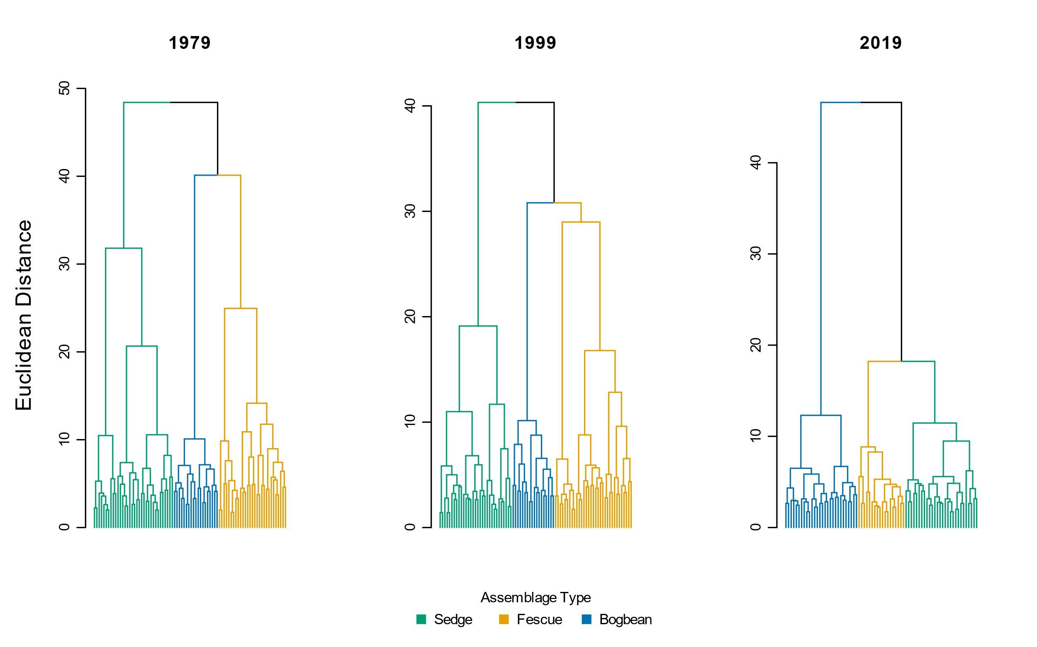

Figure Species cover abundance becomes more dissimilar in each assemblage over time, as shown by greater Euclidean distance between assemblage types. Note clusters of the sedge and fescue assemblages are more similar in 2019

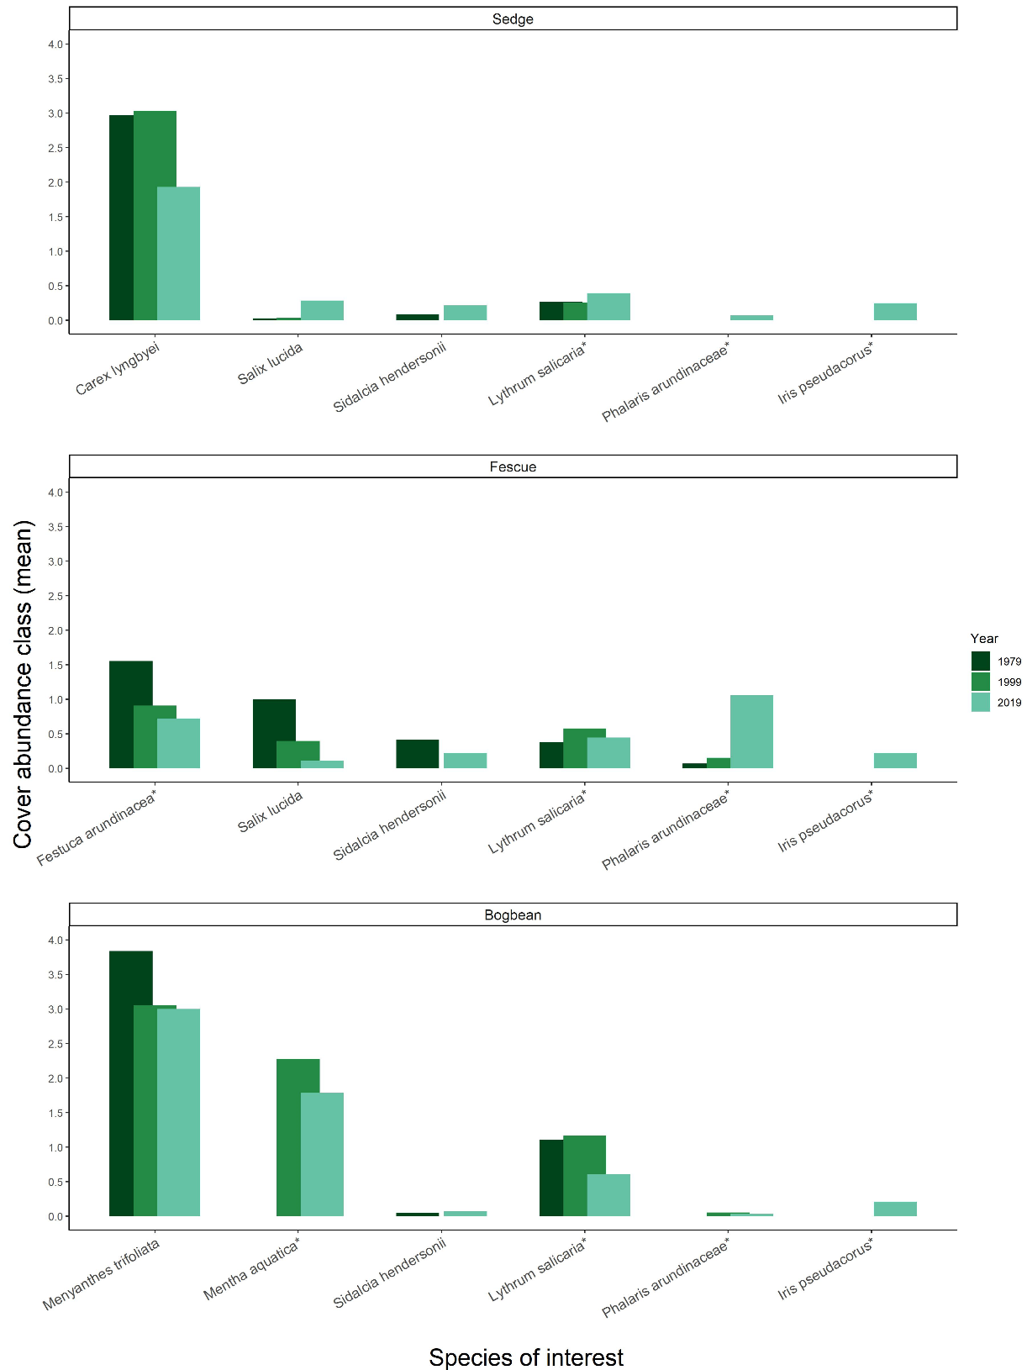

Figure Assemblage-defining species within each assemblage have decreased in abundance over time, while several exotic species (denoted by (*)) have increased in cover abundance since 1979. Cover classes are: [1] = < 25%, [2] = 25-50%, [3] = 51-75%, [4] = >75% above-ground vegetated cover.

# Discussion

Despite conservation status and general resilience of the Fraser River marsh ecosystem we found substantive changes in species composition over a 40 year time-frame, potentially indicating broader-scale processes affected by regional pressures. The three species most significantly characterizing the three plant assemblages, Sedge, Fescue and Bogbean, have remained the same over the past 40 years, supporting our expectation that these characteristic species should not change in the absence of significant disturbance. We observed a decline of native species richness accompanied by an increased richness and abundance of exotic species, which may indicate a loss of community stability. This potential instability may further be evidenced by the homogenization of cover abundance within assemblages and overall loss of indicator species for the Sedge and Fescue assemblages. Our results present a compelling case example of broader global trends of native species biodiversity loss, and should be of concern to estuary managers whose objectives are to conserve wildlife habitat and intertidal shoreline stability.

The changing identity of species or functional traits in an assemblage may offer clues to shifting abiotic conditions within or between assemblages (Waller et al., 2020). One functional group to note were the woody species, as their traits convey different structural habitat qualities than herbaceous species. Willow (*Salix* *lucida* Muhl.) was most prevalent in the Fescue assemblage in 1979, but was most abundant in the Sedge assemblage in 2019. This could suggest long-term shifts in edaphic factors and/or the competitive encroachment of exotic reed canary grass (*Phalaris arundinaceae*), making the Fescue assemblage less hospitable to willow recruitment. Alternatively, this could indicate that environmental conditions are becoming more similar between the two assemblages, as evidenced by the clustering of the Fescue and Sedge groups on the same branch in the 2019 dendrogram (Figure 2). The indicator species analysis for the Sedge assemblage in 1979 included plants tolerant of highly saturated soils (*Sagittaria latifolia, Schoenoplectus tabernaemontani*), but in 1999 the assemblage indicators included species less tolerant of aquatic or constantly saturated soils (*Impatiens capensis*) ().

In contrast, the turnover of indicator species may simply represent high interannual variation in species compositional abundance, despite being a perennial-dominated community. For example, the Bogbean assemblage, was indicated largely by unique forbs in 1979 and 2019, and an even mix of unique forbs and graminoids in 1999 (). In the Bogbean assemblage it is harder to ascribe inference, such as potential woody riparian succession, to the replacement of forb indicator species as in the Sedge and Fescue assemblages. The indicator graminoid species found only in 1999 in the Bogbean assemblage (excluding an unknown grass identified only to family) are all native wetland species commonly found in high marshes. Rather than indicating altered abiotic conditions, their inclusion as indicator species may represent population dynamics of short-lived perennials such as dispersal and recruitment. Thus, we propose two potential alternative hypotheses for the observed changes in floristic composition observed in the different assemblages: greater compositional abundance of woody species or species tolerant of drier conditions could be indicative of channel morphology processes limiting bank topography suitable for aquatic emergent plants, or sedimentation feedback processes increasing elevation of the marsh platform relative to tidal inundation. Alternatively, population dynamics may be operating independently of abiotic conditions, or have different outcomes depending on edaphic conditions in each assemblage. Testing how life histories (e.g., species longevity) offer competitive advantage in the context of changing abiotic conditions would be a valuable long-term addition to general interactions of competition and edaphic factors. These interactions would present a valuable experimental test of competitive advantage or how edaphic conditions drive the dominance of native vs. exotic species in tidal wetlands.

Greater homogeneity of cover abundance within assemblages, and greater distinction in compositional abundance between assemblages, may result from overall loss of native floristic richness. Across all assemblages in Ladner Marsh 1979-2019, plots had on average one to two fewer native species, while β-diversity increased. This would indicate that rare (infrequently found) species are becoming more locally rare, which contributes to the loss of heterogeneous cover abundance and increased β-diversity observed at the plot scale. With the exception of woody species gained, the life histories and ecosystem functional traits of the species gained are similar to those lost from Ladner Marsh. More concerning is the net loss of six perennial graminoid and forb species over the study period, as this represents a loss of functional redundancy from the ecosystem. Biodiversity loss may reduce the dense root networks to trap sediment in the marsh platform and seasonal pollinator value of forbs, although these contributions by the species lost in Ladner Marsh have not been quantified. Regardless of whether the loss is due to turnover or shifting abiotic conditions, trends of lost species richness may indicate greater susceptibility to invasion (Kuiters, *et al.*, 2009), and thus a loss of resistance to exotic species encroachment over time. This can be evidenced by the decreasing ratio of native to exotic cover across Ladner Marsh 1979-2019 (Figure 5), although few species (native or exotic) represent the majority of cover within the assemblage (Table 7). Exotic species of significant management concern (e.g., *P. arundinaceae*, *I. pseudacorus*)) were < 25% mean plot cover in 2019, however these species are notorious for spreading to the point of near-exclusion of other species (especially natives) (Apfelbaum & Sams, 1987; Sinks et al., 2021).

## Mechanisms, Synthesis & Recommendations

Exotic species encroachment and native species loss may lead to instability in native populations through fragmented or lost propagule dispersal networks, resulting in ecosystem instability through altered trophic cascades and implications for endangered species. Disentangling explicit impacts of sedimentation, propagule dispersal, or propagule recruitment processes would be no easy task in a tidal ecosystem, however experimentally testing optimal recruitment niches of species-specific propagules (e.g., Lane, 2022) could prove valuable for understanding best practices to maintain at-risk populations or test community function. Optimal abiotic conditions for the recruitment and spatial occupancy of native or exotic species may largely be driven by soil characteristics and related sedimentation processes. Sedimentary changes such as sediment starvation or subsidence would result in more saturated areas, which would likely drive the increased prevalence of saturated conditions favored by the Bogbean assemblage (Mendelssohn & Kuhn, 2003). Alternatively, positive feedbacks between vegetation and sedimentation could support areas of marsh accretion (Nyman et al., 2006), which may also be more likely to receive exotic propagules within the distributed sediment. Propagule pools would depend on local and regional proximity. If similar habitats within tidal estuarine ecosystems are lost to the point where distance between patches exceeds propagule dispersal distance (Shi, et al., 2020), then species colonization within the ecosystem is rare or lost. Alternatively, if exotic species are more prevalent throughout the regional dispersal network, then there is a greater chance of exotic species introduction within a local marsh community. Thus, abiotic shifts may be altering the seed recruitment niches which may restrict recruitment of native species diversity, while dispersal networks may be delivering disproportionately more seed of exotic species. This reflects a general trend of exotic species’ competitive advantage in disturbed systems, and represents ongoing press disturbance by anthropogenic impacts with cumulative ecosystem effects.

A common (mis)assumption is that ‘undisturbed’ areas represent ecologically appropriate reference states (e.g., Stoddard, et al., 2006, and citations therein). Our findings support that contemporary “reference” sites are not sufficient benchmarks for restoration success (Shackelford, et al., 2021). The biodiversity loss described here presents real concerns for this conservation area, and provides another case example of negative biodiversity trends in habitat considered relatively pristine. Active management informed by experimental testing of hydrogeomorphologic drivers, dispersal networks, and recruitment strategies will be needed to maintain ecologically desired species composition in the face of climate change. If we are to prioritize conservation of functional coastal wetlands that include a significant representation of native species, we must seek new ways to actively manage habitats such as the Ladner Marsh. Through control of invasive species and experimental management practices to employ sediment application and/or native species planting, practitioners may enhance ecosystem processes within remnant coastal wetland habitats. This active management process also presents a timely and necessary opportunity in the Pacific Northwest of North America to engage with First Nations to revive traditional management practices in tidal wetlands, such as select mechanical disturbance (Turner, 2014): working with traditional knowledge holders in these ecosystems may yield deeper understanding of plant community function and habitat stability, which would enhance ecosystem resilience and potentially lead to positive effects on regionally important salmonid and shorebird populations while contributing to reconciliation between Indigenous and colonial cultures.

# Statements & Declarations

## Funding

Financial support for 2019 field surveys was provided by Natural Sciences and Engineering Research Council of Canada Discovery Grant RGPIN-2018-03838 to J. Richardson (University of British Columbia). Support for analysis and manuscript writing was supported by Liber Ero Chair in Conservation to Tara G. Martin, and a Mitacs Accelerate Fellowship to Stefanie L. Lane.

## Competing interests

The authors have no relevant financial or non-financial interests to disclose.

## Author contributions

Study conception, design, 2019 data collection, and analysis were exclusively undertaken by Stefanie L. Lane. Original (1979) study concept comparing plant assemblages, data collection, and analysis were performed or overseen by Gary Bradfield. Madlen Denoth contributed data collected in 1999. Nancy Shackelford assisted with theoretical framework and manuscript revision. Manuscript was drafted by Stefanie L. Lane; Nancy Shackelford and Tara G. Martin commented on previous versions of the manuscript. All authors read and approved the final manuscript.

## Data availability

Data for all years of observation are available on Dryad (DOI). Code is available on GitHub (REPO), or via Dryad (DOI)

# Literature Cited

Apfelbaum, S. I., & Sams, C. E. (1987). Ecology and Control of Reed Canary Grass (Phalaris arundinacea L.). *Natural Areas Journal*, *7*(2), 69–74.

Bradfield, G. E., & Porter, G. L. (1982). Vegetation structure and diversity components of a Fraser estuary tidal marsh. *Canadian Journal of Botany*, *60*(4), 440–451. https://doi.org/10.1139/b82-060

Brophy, L. S., Greene, C. M., Hare, V. C., Holycross, B., Lanier, A., Heady, W. N., O’Connor, K., Imaki, H., Haddad, T., & Dana, R. (2019). Insights into estuary habitat loss in the western United States using a new method for mapping maximum extent of tidal wetlands. *PLOS ONE*, *14*(8), e0218558. https://doi.org/10.1371/journal.pone.0218558

Chalifour, L., Scott, D. C., MacDuffee, M., Iacarella, J. C., Martin, T. G., & Baum, J. K. (2019). Habitat use by juvenile salmon, other migratory fish, and resident fish species underscores the importance of estuarine habitat mosaics. *Marine Ecology Progress Series*, *625*, 145–162. https://doi.org/10.3354/meps13064

Davis, M. J., Woo, I., Ellings, C. S., Hodgson, S., Beauchamp, D. A., Nakai, G., & De La Cruz, S. E. W. (2021). A climate-mediated shift in the estuarine habitat mosaic limits prey availability and reduces nursery quality for juvenile salmon. *Estuaries and Coasts*. https://doi.org/10.1007/s12237-021-01003-3

De Cáceres, M., & Jansen, F. (2016). *Indicspecies*. http://r.meteo.uni.wroc.pl/web/packages/indicspecies/indicspecies.pdf

Denoth, M., & Myers, J. H. (2007). Competition between Lythrum salicaria and a rare species: Combining evidence from experiments and long-term monitoring. *Plant Ecology*, *191*(2), 153–161. https://doi.org/10.1007/s11258-006-9232-2

Donohue, I., Hillebrand, H., Montoya, J. M., Petchey, O. L., Pimm, S. L., Fowler, M. S., Healy, K., Jackson, A. L., Lurgi, M., McClean, D., O’Connor, N. E., O’Gorman, E. J., & Yang, Q. (2016). Navigating the complexity of ecological stability. *Ecology Letters*, *19*(9), 1172–1185. https://doi.org/10.1111/ele.12648

Douglas, T. J., Schuerholz, G., & Juniper, S. K. (2022). Blue Carbon Storage in a Northern Temperate Estuary Subject to Habitat Loss and Chronic Habitat Disturbance: Cowichan Estuary, British Columbia, Canada. *Frontiers in Marine Science*, *9*. https://www.frontiersin.org/article/10.3389/fmars.2022.857586

Dufrêne, M., & Legendre, P. (1997). Species Assemblages and Indicator Species:the Need for a Flexible Asymmetrical Approach. *Ecological Monographs*, *67*(3), 345–366. https://doi.org/10.1890/0012-9615(1997)067[0345:SAAIST]2.0.CO;2

Emmett, R., Llansó, R., Newton, J., Thom, R., Hornberger, M., Morgan, C., Levings, C., Copping, A., & Fishman, P. (2000). Geographic signatures of North American West Coast estuaries. *Estuaries*, *23*(6), 765–792. http://dx.doi.org/10.2307/1352998

Finn, R. J. R., Chalifour, L., Gergel, S. E., Hinch, S. G., Scott, D. C., & Martin, T. G. (2021). Quantifying lost and inaccessible habitat for Pacific salmon in Canada’s Lower Fraser River. *Ecosphere*, *12*(7), e03646. https://doi.org/10.1002/ecs2.3646

Hallett, L. M., Jones, S. K., MacDonald, A. A. M., Jones, M. B., Flynn, D. F. B., Ripplinger, J., Slaughter, P., Gries, C., & Collins, S. L. (2016). codyn: An r package of community dynamics metrics. *Methods in Ecology and Evolution*, *7*(10), 1146–1151. https://doi.org/10.1111/2041-210X.12569

Hanski, I. (1982). Dynamics of Regional Distribution: The Core and Satellite Species Hypothesis. *Oikos*, *38*(2), 210–221. JSTOR. https://doi.org/10.2307/3544021

Hitchcock, C. L., & Cronquist, A. (1973). *Flora of the Pacific Northwest, an illustrated manual*. University of Washington Press.

Holling, C. S. (1973). Resilience and Stability of Ecological Systems. *Annual Review of Ecology and Systematics*, *4*(1), 1–23. https://doi.org/10.1146/annurev.es.04.110173.000245

Kehoe, L. J., Lund, J., Chalifour, L., Asadian, Y., Balke, E., Boyd, S., Carlson, D., Casey, J. M., Connors, B., Cryer, N., Drever, M. C., Hinch, S., Levings, C., MacDuffee, M., McGregor, H., Richardson, J., Scott, D. C., Stewart, D., Vennesland, R. G., … Martin, T. G. (2021). Conservation in heavily urbanized biodiverse regions requires urgent management action and attention to governance. *Conservation Science and Practice*, *3*(2), e310. https://doi.org/10.1111/csp2.310

Kopecký, M., & Macek, M. (2015). Vegetation resurvey is robust to plot location uncertainty. *Diversity and Distributions*, *21*(3), 322–330. https://doi.org/10.1111/ddi.12299

Lane, S. L. (2022). Using marsh organs to test seed recruitment in tidal freshwater marshes. *Applications in Plant Sciences*, *n/a*, e11474. https://doi.org/10.1002/aps3.11474

Legendre, P., & Legendre, L. (2012). *Numerical Ecology* (3rd ed., Vol. 24). Elsevier.

Lepš, J. (2004). What do the biodiversity experiments tell us about consequences of plant species loss in the real world? *Basic and Applied Ecology*, *5*(6), 529–534. https://doi.org/10.1016/j.baae.2004.06.003

Mendelssohn, I. A., & Kuhn, N. L. (2003). Sediment subsidy: Effects on soil–plant responses in a rapidly submerging coastal salt marsh. *Ecological Engineering*, *21*(2), 115–128. https://doi.org/10.1016/j.ecoleng.2003.09.006

Nyman, J. A., Walters, R. J., Delaune, R. D., & Patrick, W. H. (2006). Marsh vertical accretion via vegetative growth. *Estuarine, Coastal and Shelf Science*, *69*(3), 370–380. https://doi.org/10.1016/j.ecss.2006.05.041

Ovaskainen, O., Rybicki, J., & Abrego, N. (2019). What can observational data reveal about metacommunity processes? *Ecography*, *42*(11), 1877–1886. https://doi.org/10.1111/ecog.04444

Pasternack, G. B. (2009). Chapter 3. Hydrogeomorphology and sedimentation in tidal freshwater wetlands. In A. Barendregt, D. F. Whigham, & A. H. Baldwin (Eds.), *Tidal Freshwater Wetlands* (pp. 31–40). Backhuys Publishers.

Schaefer, V. (2004). Ecological setting of the Fraser River delta and its urban estuary. In B. J. Groulx, D. C. Mosher, J. L. Luternauer, & D. E. Bilderback (Eds.), *Fraser River Delta, British Columbia: Issues of an Urban Estuary* (pp. 147–172). Geological Survey of Canada, Bulletin 547.

Shackelford, N., Dudney, J., Stueber, M. M., Temperton, V. M., & Suding, K. L. (2021). Measuring at all scales: Sourcing data for more flexible restoration references. *Restoration Ecology*, *n/a*(n/a), e13541. https://doi.org/10.1111/rec.13541

Shi, W., Shao, D., Gualtieri, C., Purnama, A., & Cui, B. (2020). Modelling long-distance floating seed dispersal in salt marsh tidal channels. *Ecohydrology*, *13*(1), e2157. https://doi.org/10.1002/eco.2157

Sinks, I. A., Borde, A. B., Diefenderfer, H. L., & Karnezis, J. P. (2021). Assessment of Methods to Control Invasive Reed Canarygrass (Phalaris arundinacea) in Tidal Freshwater Wetlands. *Natural Areas Journal*, *41*(3), 172–185. https://doi.org/10.3375/043.041.0303

Stoddard, J. L., Larsen, D. P., Hawkins, C. P., Johnson, R. K., & Norris, R. H. (2006). Setting Expectations for the Ecological Condition of Streams: The Concept of Reference Condition. *Ecological Applications*, *16*(4), 1267–1276. https://doi.org/10.1890/1051-0761(2006)016[1267:SEFTEC]2.0.CO;2

Turner, N. (2014). *Ancient Pathways, Ancestral Knowledge: Ethnobotany and Ecological Wisdom of Indigenous Peoples of Northwestern North America*. McGill-Queen’s Press - MQUP.

Underwood, A. J., Chapman, M. G., & Connell, S. D. (2000). Observations in ecology: You can’t make progress on processes without understanding the patterns. *Journal of Experimental Marine Biology and Ecology*, *250*(1), 97–115. https://doi.org/10.1016/S0022-0981(00)00181-7

Waller, L. P., Allen, W. J., Barratt, B. I. P., Condron, L. M., França, F. M., Hunt, J. E., Koele, N., Orwin, K. H., Steel, G. S., Tylianakis, J. M., Wakelin, S. A., & Dickie, I. A. (2020). Biotic interactions drive ecosystem responses to exotic plant invaders. *Science*, *368*(6494), 967–972. https://doi.org/10.1126/science.aba2225

Whittaker, R. H. (1975). *Communities and Ecosystems* (2nd ed.). Macmillan.

# Supplemental

Table . A total of 25 plots sampled in 1979 and 1999 were not sampled in 2019, mostly due to issues of accessibility. Transect names and plot ID of plots omitted follow Fig. 3 in Bradfield & Porter (1982).

|  |  |  |
| --- | --- | --- |
| **Transect** | **1979/1999**  **Plot No.** | **Reason omitted in 2019** |
| Q | 1-7 | Transect in dense riparian thicket overgrown with Himalayan blackberry |
| R | 8 | Plot on lower bench (> 1 m lower than marsh platform), vegetation no longer exists |
| R | 17-19 | Plots in 1979 & 1999 sampled across a channel. Ended transect in 2019 at channel edge. |
| S | 33-36 | Transect length in 2019 was shorter than in 1979/1999. Suspect combination of erosion and offset transect relocation altered sampling distance. |
| T | 45 | Transect length in 2019 was shorter than in 1979/1999. Suspect combination of erosion and offset transect relocation altered sampling distance. |
| U | 51-52 | Transect length in 2019 was shorter than in 1979/1999. Suspect combination of erosion and offset transect relocation altered sampling distance. |
| V | 53 | Plot 53 only plot across a channel. Increased channel width and likely erosion made crossing this channel dangerous; omitted plot in 2019. |
| V | 54, 70-71 | Transect length in 2019 was shorter than in 1979/1999. Suspect combination of erosion and offset transect relocation altered sampling distance. |
| W | 89-92 | Transect length in 2019 was shorter than in 1979/1999. Suspect combination of erosion and offset transect relocation altered sampling distance. |
| X | 93 | Transect length in 2019 was shorter than in 1979/1999. Suspect combination of erosion and offset transect relocation altered sampling distance. |

*Table 4. Species indicator analysis of cluster groups using Bray-Curtis distance identifies the same dominant species in each assemblage type (Sedge, Fescue, Bogbean), however Bray-Curtis distance identifies different associated indicator species than those identified by Euclidean distance ().*

|  |  |  |  |  |  |  |  |  |  |  |  |
| --- | --- | --- | --- | --- | --- | --- | --- | --- | --- | --- | --- |
|  | **1979** | | |  | **1999** | | |  | **2019** | | |
| **Cluster Group Name** | **Species** | **IndVal stat** | **p-value** |  | **Species** | **IndVal stat** | **p-value** |  | **Species** | **IndVal stat** | **p-value** |
|  |  |  |  |  |  |  |  |  |  |  |  |
| "Sedge" | *Carex lyngbyei* | 0.678 | 0.001 |  | *Carex lyngbyei* | 0.804 | 0.001 |  | *Carex lyngbyei* | 0.714 | 0.001 |
| *Sagittaria latifolia* | 0.559 | 0.001 |  | *Agrostis stolonifera* | 0.434 | 0.003 |  | *Mentha arvensis* | 0.322 | 0.033 |
| *Schoenoplectus tabernaemontani* | 0.391 | 0.001 |  |  |  |  |  |  |  |  |
|  |  |  |  |  |  |  |  |  |  |  |
|  |  |  |  |  |  |  |  |  |  |  |  |
| "Fescue" | *Festuca arundinacea* | 0.753 | 0.001 |  | *Festuca arundinacea* | 0.765 | 0.001 |  | *Phalaris arundinaceae* | 0.584 | 0.001 |
| *Salix lucida* | 0.586 | 0.001 |  | *Phalaris arundinaceae* | 0.334 | 0.019 |  | *Festuca arundinacea* | 0.416 | 0.001 |
| *Lathyrus palustris* | 0.543 | 0.001 |  |  |  |  |  |  |  |  |
| *Equisetum palustre* | 0.475 | 0.002 |  |  |  |  |  |  |  |  |
| *Impatiens capensis* | 0.391 | 0.002 |  |  |  |  |  |  |  |  |
| *Sidalcia hendersonii* | 0.387 | 0.001 |  |  |  |  |  |  |  |  |
| *Platanthera dilatata* | 0.308 | 0.020 |  |  |  |  |  |  |  |  |
|  |  |  |  |  |  |  |  |  |  |  |  |
| "Bogbean" | *Menyanthes trifoliata* | 0.807 | 0.001 |  | *Menyanthes trifoliata* | 0.782 | 0.001 |  | *Mentha aquatica* | 0.752 | 0.001 |
| *Myosotis scorpioides* | 0.577 | 0.001 |  | *Leersia oryzoides* | 0.495 | 0.001 |  | *Menyanthes trifoliata* | 0.709 | 0.001 |
| *Juncus articulatus* | 0.523 | 0.001 |  | *Mentha aquatica* | 0.492 | 0.001 |  | *Lysimachia thyrsiflora* | 0.547 | 0.001 |
| *Lythrum salicaria* | 0.400 | 0.002 |  | *Bidens cernua* | 0.489 | 0.003 |  | *Salix lucida* | 0.465 | 0.001 |
| *Lysimachia thyrsiflora* | 0.400 | 0.002 |  | *Lysimachia thyrsiflora* | 0.478 | 0.001 |  | *Eleocharis palustris* | 0.460 | 0.001 |
| *Trifolium wormskjoldii* | 0.381 | 0.003 |  | *Juncus articulatus* | 0.438 | 0.001 |  | *Juncus articulatus* | 0.373 | 0.004 |
| *Lilaeopsis occidentalis* | 0.360 | 0.004 |  | *Juncus oxymeris* | 0.356 | 0.015 |  | *Galium trifidum* | 0.348 | 0.008 |
| *Mentha aquatica* | 0.313 | 0.010 |  | *Myosotis scorpioides* | 0.356 | 0.019 |  | *Bidens cernua* | 0.323 | 0.012 |
|  |  |  |  | Poaceae (unidentified sp.) | 0.356 | 0.013 |  |  |  |  |
|  |  |  |  | *Deschampsia caespitosa* | 0.354 | 0.014 |  |  |  |  |
|  |  |  |  | *Sagittaria latifolia* | 0.301 | 0.046 |  |  |  |  |

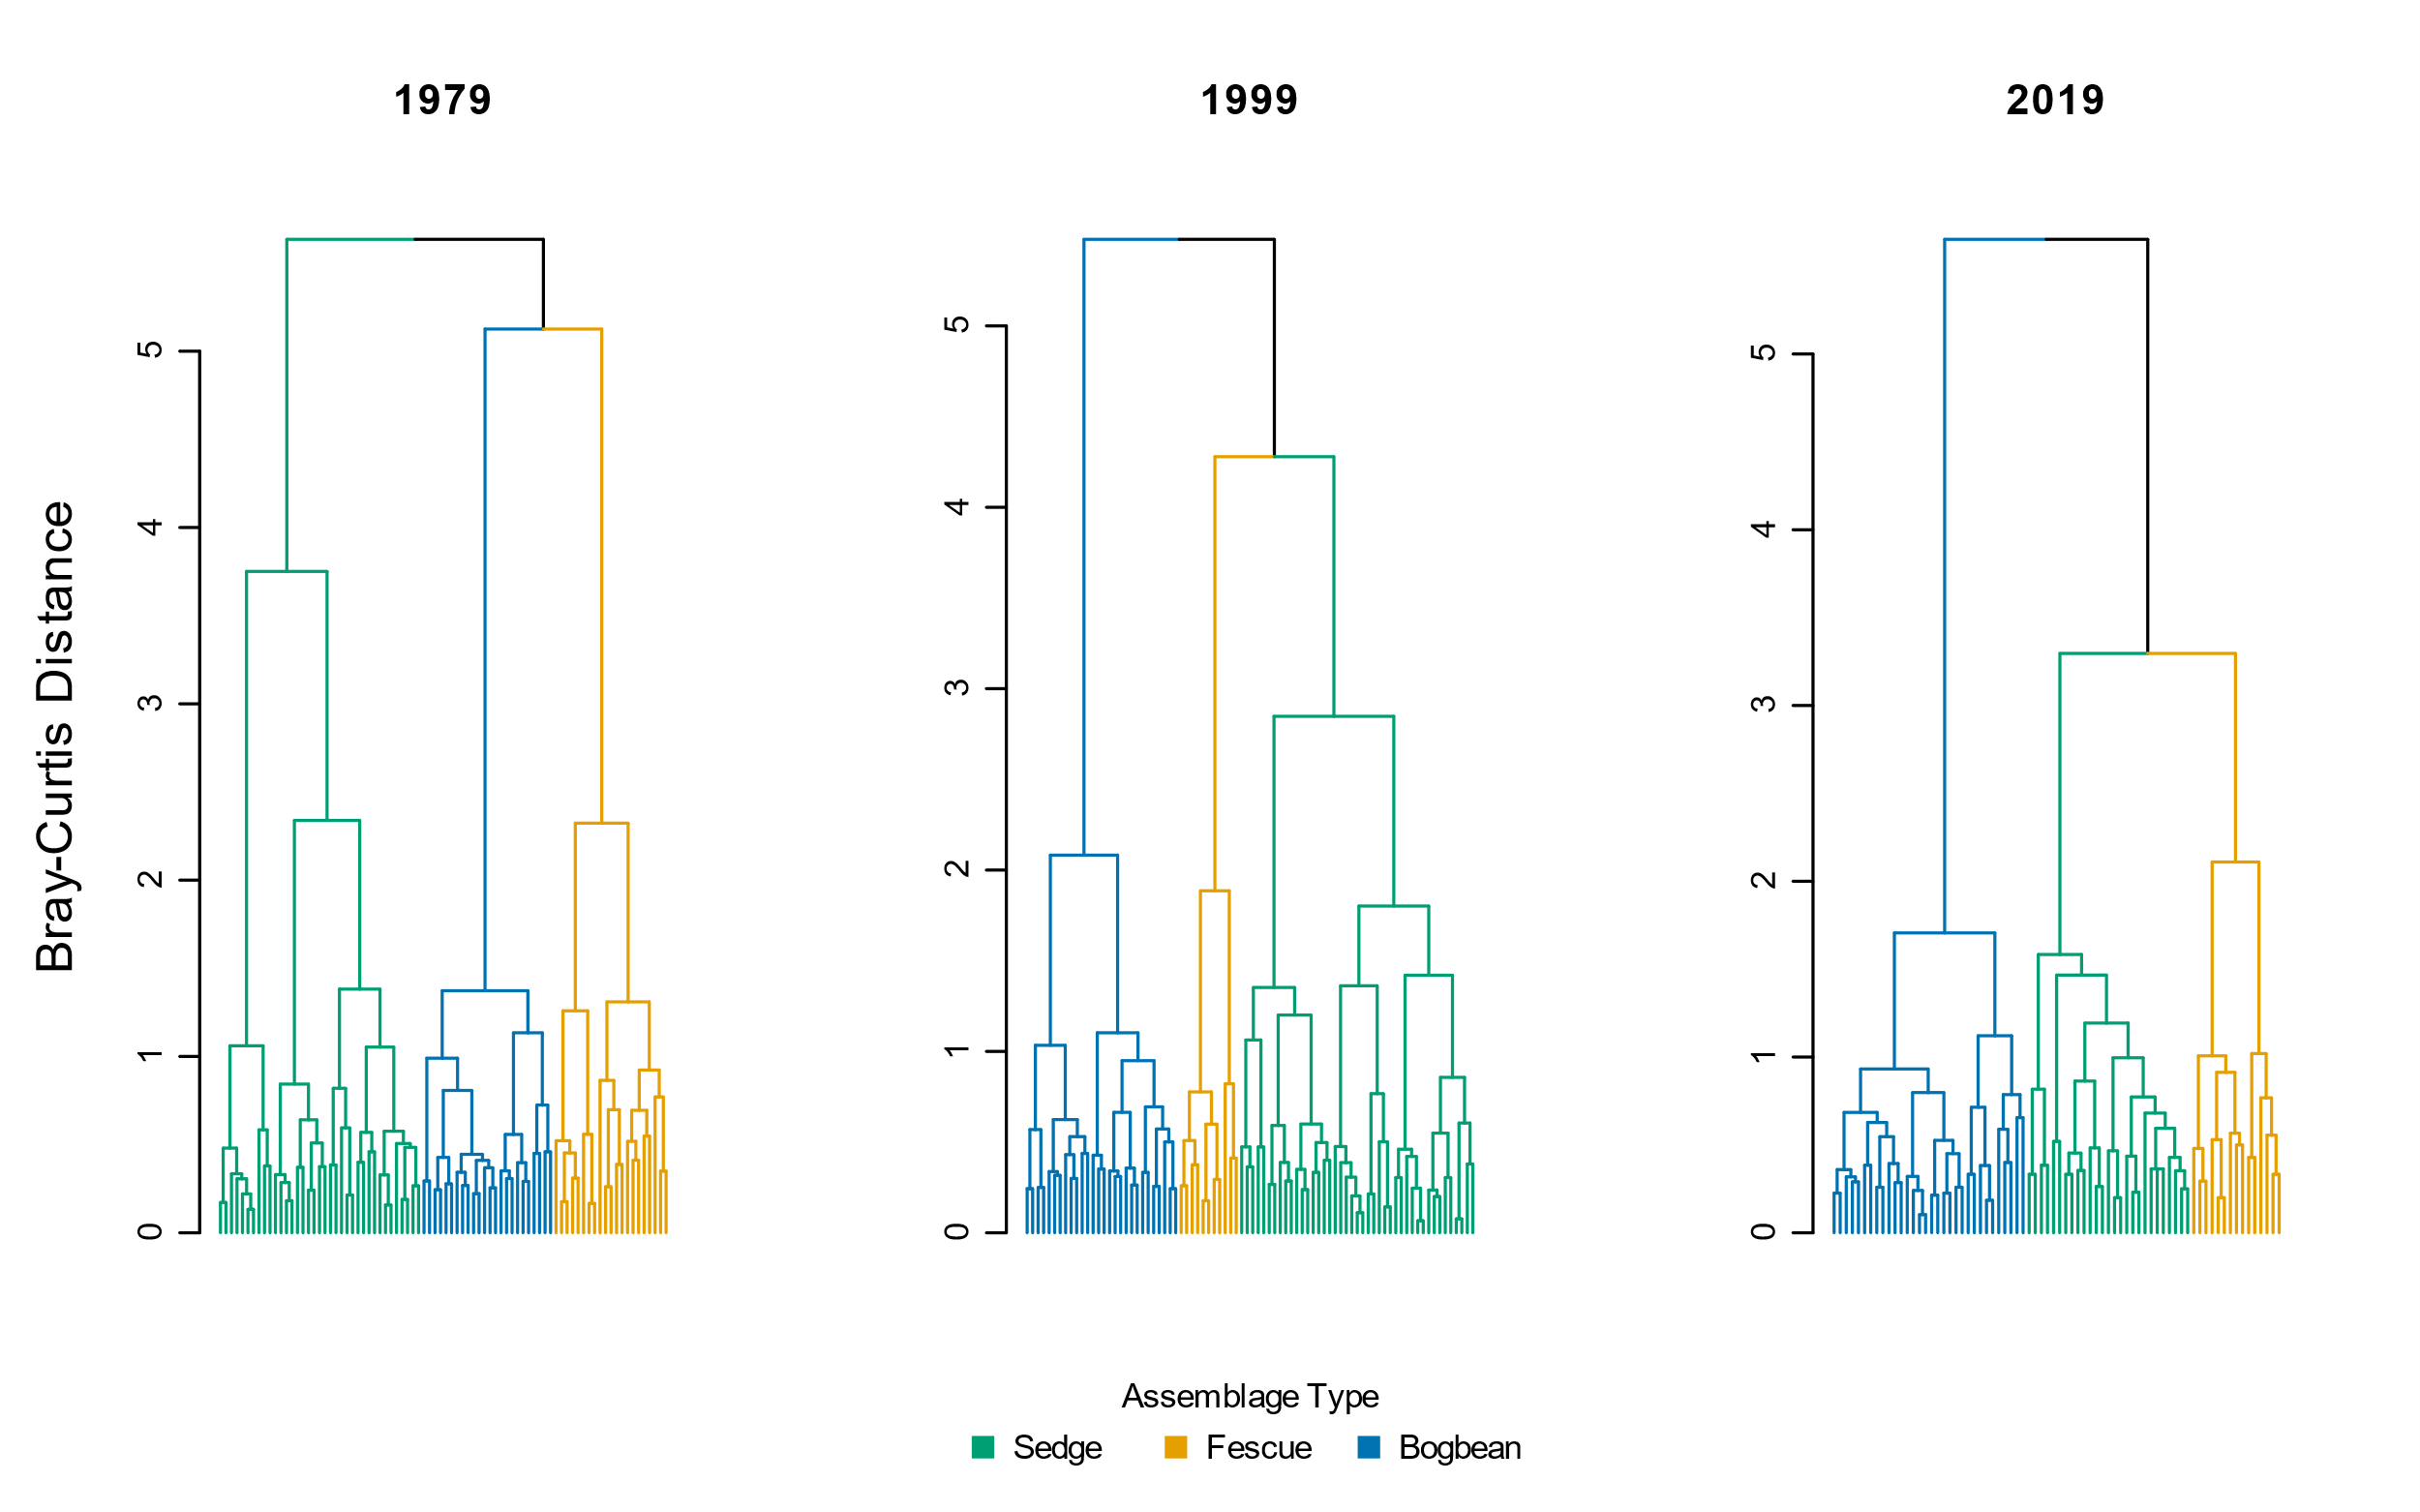

Figure . Cluster analysis using Bray-Curtis distance measure shows similar trends of increasing dissimilarity over time as when using Euclidean distance (Figure 2).

|  |  |  |  |  |  |  |
| --- | --- | --- | --- | --- | --- | --- |
|  | **Plot-level components** | |  | **Diversity components** | | |
| **Assemblage** | **No. quadrats** | **No. species** |  | **α diversity** | **α diversity sd** | **β diversity** |
| **Sedge** |  |  |  |  |  |  |
| 1979 | 18 | 32.3 |  | 10.67 | 2.34 | 3.03 |
| 1999 | 18 | 31.6 |  | 8.31 | 1.98 | 3.81 |
| 2019 | 18 | 30.8 |  | 8.18 | 2.51 | 3.77 |
|  |  |  |  |  |  |  |
| **Fescue** |  |  |  |  |  |  |
| 1979 | 18 | 43.3 |  | 12.96 | 3.91 | 3.35 |
| 1999 | 18 | 36.4 |  | 9.72 | 3.92 | 3.76 |
| 2019 | 18 | 27 |  | 5.83 | 2.79 | 4.63 |
|  |  |  |  |  |  |  |
| **Bogbean** |  |  |  |  |  |  |
| 1979 | 18 | 31.7 |  | 12.83 | 3.63 | 2.47 |
| 1999 | 18 | 36 |  | 11.50 | 2.92 | 3.13 |
| 2019 | 18 | 31.4 |  | 10.52 | 1.90 | 2.99 |
|  |  |  |  |  |  |  |
| **Total** |  |  |  |  |  |  |
| 1979 | 54 | 47.6 |  | 12.15 | 3.49 | 3.92 |
| 1999 | 54 | 42.1 |  | 10.02 | 3.35 | 4.22 |
| 2019 | 54 | 41.7 |  | 8.18 | 3.08 | 5.10 |

Table . Bootstrapping 18 randomly selected plots 10 times shows consistent overall trend in loss of species and alpha diversity over time, and overall increase in beta diversity between 1979 and 2019 in all assemblages and across the entire Ladner Marsh plant community. Therefore, loss of plots due to sampling re-location or how number of plots clustered into assemblages as reported in Table 2 is not expected to affect loss of species or plot-based diversity metrics.

Table 6. Total turnover and rates of species disappearance (loss) was always greater between 1999 and 2019 than between 1979 and 1999. However, fewer species were gained in the Bogbean assemblage 1999-2019 than 1979-1999.

|  |  |  |  |  |
| --- | --- | --- | --- | --- |
| **Assemblage** | **Year** | **Total turnover** | **Species Appearance** | **Species Disappearance** |
| Bogbean | 1979-1999 | 0.56 | 0.35 | 0.22 |
| 1999-2019 | 0.60 | 0.28 | 0.32 |
| Fescue | 1979-1999 | 0.46 | 0.20 | 0.27 |
| 1999-2019 | 0.64 | 0.18 | 0.46 |
| Sedge | 1979-1999 | 0.46 | 0.24 | 0.22 |
| 1999-2019 | 0.56 | 0.27 | 0.29 |

Table . Mean cover class values for non-native and native species observed in each assemblage for the three sampling periods. New species appearances from 1979 to 2019 indicated by (+); species only appearing in 1999 indicated by ‘NA’. Native status is listed as ‘unknown’ if plant was not identified to species level.

|  |  |  |  |  |  |  |
| --- | --- | --- | --- | --- | --- | --- |
| **Assemblage** | **Status** | **Species** | **1979** | **1999** | **2019** | **Percent Change (1979-2019)** |
| Bogbean | Non-native | *Mentha arvensis* | 0.47 | 0.00 | 0.07 | -84.9 |
| *Myosotis scorpiodes* | 0.68 | 0.22 | 0.21 | -68.7 |
| *Agrostis stolonifera* | 3.21 | 1.50 | 1.29 | -60.0 |
| *Lythrum salicaria* | 1.11 | 1.17 | 0.61 | -45.1 |
| *Rumex conglomeratus* | 0.05 | 0.00 | 0.04 | -32.1 |
| *Mentha aquatica* | 0.37 | 2.28 | 1.79 | 384.7 |
| *Iris pseudocorus* | 0.00 | 0.33 | 0.21 | + |
| *Lycopus europaeus* | 0.00 | 0.00 | 0.04 | + |
| *Phalaris arundinacea* | 0.00 | 0.06 | 0.04 | + |
| *Festuca arundinacea* | 0.00 | 0.17 | 0.00 | NA |
| Native | *Alisma plantago aquatica* | 0.16 | 0.11 | 0.00 | -100.0 |
| *Alopecurus geniculatus* | 0.05 | 0.00 | 0.00 | -100.0 |
| *Deschampsia caespitosa* | 0.26 | 0.22 | 0.00 | -100.0 |
| *Equisetum fluviatile* | 1.37 | 1.17 | 0.00 | -100.0 |
| *Leersia oryzoides* | 0.26 | 0.33 | 0.00 | -100.0 |
| *Lilaeopsis occidentalis* | 0.21 | 0.00 | 0.00 | -100.0 |
| *Oenanthe sarmentosa* | 0.63 | 0.11 | 0.00 | -100.0 |
| *Poa trivialis* | 0.11 | 0.00 | 0.00 | -100.0 |
| *Sium suave* | 0.63 | 0.17 | 0.00 | -100.0 |
| *Caltha palustris* | 0.95 | 0.22 | 0.07 | -92.5 |
| *Bidens cernua* | 0.84 | 0.17 | 0.14 | -83.0 |
| *Trifolium wormskjoldii* | 0.95 | 0.11 | 0.18 | -81.2 |
| *Schoenoplectus tabernaemontani* | 0.16 | 0.00 | 0.07 | -54.8 |
| *Eleocharis palustris* | 0.63 | 0.78 | 0.39 | -37.8 |
| Symphyotrichum *subspicatum* | 0.47 | 0.33 | 0.32 | -32.1 |
| *Juncus oxymeris* | 0.05 | 0.11 | 0.04 | -32.1 |
| *Platanthera dilatata* | 0.05 | 0.06 | 0.04 | -32.1 |
| *Menyanthes trifoliata* | 3.84 | 3.06 | 3.00 | -21.9 |
| *Lysimachia thyrsiflora* | 0.53 | 0.22 | 0.57 | 8.6 |
| *Juncus articulatus* | 0.26 | 0.39 | 0.29 | 8.6 |
| *Sidalcea hendersonii* | 0.05 | 0.00 | 0.07 | 35.7 |
| *Carex lyngbyei* | 0.47 | 0.33 | 1.00 | 111.1 |
| *Rumex occidentalis* | 0.05 | 0.11 | 0.14 | 171.4 |
| *Potentilla anserina-pacifica* | 0.26 | 1.00 | 1.07 | 307.1 |
| *Equisetum arvense* | 0.00 | 0.00 | 0.64 | + |
| *Galium trifidum* | 0.00 | 0.00 | 0.39 | + |
| *Hypericum scouleri* | 0.00 | 0.00 | 0.04 | + |
| *Impatiens capensis* | 0.00 | 0.44 | 0.32 | + |
| *Juncus acuminatus* | 0.00 | 0.00 | 0.04 | + |
| *Lathyrus palustris* | 0.00 | 0.11 | 0.50 | + |
| *Lysichiton americanum* | 0.00 | 0.00 | 0.07 | + |
| *Salix lasiandra* | 0.00 | 0.61 | 0.50 | + |
| *Salix scouleriana* | 0.00 | 0.00 | 0.04 | + |
| *Typha latifolia* | 0.00 | 0.28 | 0.25 | + |
| *Equisetum palustre* | 0.00 | 0.11 | 0.00 | NA |
| *Equisetum variegatum* | 0.00 | 0.11 | 0.00 | NA |
| *Galium sp.* | 0.00 | 0.06 | 0.00 | NA |
| *Poa palustris* | 0.00 | 0.50 | 0.00 | NA |
| *Poaceae sp.* | 0.00 | 0.28 | 0.00 | NA |
| *Sagittaria latifolia* | 0.00 | 0.17 | 0.00 | NA |
|  |  |  |  |  |  |  |
| **Assemblage** | **Status** | **Species** | **1979** | **1999** | **2019** | **Percent Change (1979-2019)** |
| Fescue | Unknown | *Festuca sp.* | 0.03 | 0.00 | 0.00 | -100.0 |
| Non-native | *Mentha aquatica* | 0.31 | 0.09 | 0.00 | -100.0 |
| *Myosotis scorpiodes* | 0.31 | 0.03 | 0.00 | -100.0 |
| *Mentha arvensis* | 0.17 | 0.24 | 0.06 | -67.8 |
| *Festuca arundinacea* | 1.55 | 0.91 | 0.72 | -53.5 |
| *Lythrum salicaria* | 0.38 | 0.58 | 0.44 | 17.2 |
| *Agrostis stolonifera* | 0.34 | 0.82 | 0.61 | 77.2 |
| *Phalaris arundinacea* | 0.07 | 0.15 | 1.06 | 1430.6 |
| *Cirsium arvense* | 0.00 | 0.03 | 0.06 | + |
| *Iris pseudocorus* | 0.00 | 0.15 | 0.22 | + |
| *Lycopus europaeus* | 0.00 | 0.00 | 0.06 | + |
| Native | *Alisma plantago aquatica* | 0.10 | 0.18 | 0.00 | -100.0 |
| *Alopecurus geniculatus* | 0.03 | 0.00 | 0.00 | -100.0 |
| *Bidens cernua* | 0.21 | 0.52 | 0.00 | -100.0 |
| *Deschampsia caespitosa* | 0.62 | 0.09 | 0.00 | -100.0 |
| *Dulichium arundinaceum* | 0.07 | 0.00 | 0.00 | -100.0 |
| *Eleocharis palustris* | 0.97 | 0.33 | 0.00 | -100.0 |
| *Equisetum palustre* | 0.76 | 0.09 | 0.00 | -100.0 |
| *Galium trifidum* | 0.03 | 0.00 | 0.00 | -100.0 |
| *Hypericum formosum* | 0.10 | 0.00 | 0.00 | -100.0 |
| *Juncus articulatus* | 0.52 | 0.06 | 0.00 | -100.0 |
| *Leersia oryzoides* | 0.14 | 0.24 | 0.00 | -100.0 |
| *Lilaeopsis occidentalis* | 0.17 | 0.00 | 0.00 | -100.0 |
| *Mimulus guttatus* | 0.03 | 0.00 | 0.00 | -100.0 |
| *Oenanthe sarmentosa* | 0.17 | 0.30 | 0.00 | -100.0 |
| *Platanthera dilatata* | 0.21 | 0.03 | 0.00 | -100.0 |
| *Poa palustris* | 0.55 | 1.73 | 0.00 | -100.0 |
| *Poa trivialis* | 0.31 | 0.00 | 0.00 | -100.0 |
| *Polygonum hydropiper* | 0.03 | 0.00 | 0.00 | -100.0 |
| *Sagittaria latifolia* | 0.03 | 0.15 | 0.00 | -100.0 |
| *Salix sp.* | 0.03 | 0.00 | 0.00 | -100.0 |
| *Sium suave* | 0.14 | 0.15 | 0.00 | -100.0 |
| Symphyotrichum *subspicatum* | 0.59 | 0.24 | 0.00 | -100.0 |
| *Trifolium wormskioldii* | 0.69 | 0.55 | 0.00 | -100.0 |
| *Menyanthes trifoliata* | 1.86 | 1.33 | 0.06 | -97.0 |
| *Caltha palustris* | 0.66 | 0.39 | 0.06 | -91.5 |
| *Salix lasiandra* | 1.00 | 0.39 | 0.11 | -88.9 |
| *Carex lyngbyei* | 0.76 | 1.42 | 0.11 | -85.4 |
| *Potentilla anserina-pacifica* | 0.48 | 0.64 | 0.22 | -54.0 |
| *Sidalcea hendersonii* | 0.41 | 0.18 | 0.22 | -46.3 |
| *Lysimachia thyrsiflora* | 0.10 | 0.33 | 0.06 | -46.3 |
| *Typha latifolia* | 0.69 | 0.36 | 0.44 | -35.6 |
| *Hordeum brachyantherum* | 0.17 | 0.00 | 0.11 | -35.6 |
| *Equisetum fluviatile* | 0.62 | 0.36 | 0.44 | -28.4 |
| *Schoenoplectus tabernaemontani* | 0.07 | 0.15 | 0.06 | -19.4 |
| *Lathyrus palustris* | 0.55 | 0.18 | 0.56 | 0.7 |
| *Rumex occidentalis* | 0.07 | 0.15 | 0.11 | 61.1 |
| *Impatiens capensis* | 0.28 | 0.42 | 0.61 | 121.5 |
| *Equisetum arvense* | 0.00 | 0.00 | 0.39 | + |
| *Juncus effusus* | 0.00 | 0.00 | 0.06 | + |
| *Lysichiton americanum* | 0.00 | 0.00 | 0.11 | + |
| *Myrica gale* | 0.00 | 0.00 | 0.22 | + |
| *Salix scouleriana* | 0.00 | 0.00 | 0.17 | + |
| *Asteracea sp.* | 0.00 | 0.03 | 0.00 | NA |
| *Carex sp.* | 0.00 | 0.06 | 0.00 | NA |
| *Galium sp.* | 0.00 | 0.03 | 0.00 | NA |
| *Juncus oxymeris* | 0.00 | 0.09 | 0.00 | NA |
| *Salix sitchensis* | 0.00 | 0.03 | 0.00 | NA |
|  |  |  |  |  |  |  |
| **Assemblage** | **Status** | **Species** | **1979** | **1999** | **2019** | **Percent Change (1979-2019)** |
| Sedge | Unknown | *Galium sp.* | 0.00 | 0.03 | 0.00 | NA |
| Non-native | *Myosotis scorpiodes* | 0.03 | 0.00 | 0.00 | -100.0 |
| *Mentha arvensis* | 0.29 | 0.16 | 0.04 | -87.9 |
| *Agrostis stolonifera* | 1.85 | 2.32 | 1.25 | -32.5 |
| *Lythrum salicaria* | 0.26 | 0.26 | 0.39 | 48.4 |
| *Festuca arundinacea* | 0.09 | 0.10 | 0.18 | 102.4 |
| *Iris pseudocorus* | 0.00 | 0.13 | 0.25 | + |
| *Lycopus europaeus* | 0.00 | 0.00 | 0.11 | + |
| *Mentha aquatica* | 0.00 | 0.16 | 0.54 | + |
| *Phalaris arundinacea* | 0.00 | 0.00 | 0.07 | + |
| *Cirsium arvense* | 0.00 | 0.03 | 0.00 | NA |
| Native | *Alisma plantago aquatica* | 0.35 | 0.06 | 0.00 | -100.0 |
| *Deschampsia caespitosa* | 0.21 | 0.00 | 0.00 | -100.0 |
| *Leersia oryzoides* | 0.18 | 0.19 | 0.00 | -100.0 |
| *Lilaeopsis occidentalis* | 0.06 | 0.10 | 0.00 | -100.0 |
| *Mimulus guttatus* | 0.09 | 0.00 | 0.00 | -100.0 |
| *Oenanthe sarmentosa* | 0.71 | 0.39 | 0.00 | -100.0 |
| *Platanthera dilatata* | 0.09 | 0.03 | 0.00 | -100.0 |
| *Poa palustris* | 1.00 | 0.23 | 0.00 | -100.0 |
| *Puccinella pauciflora* | 0.03 | 0.00 | 0.00 | -100.0 |
| *Sium suave* | 0.59 | 0.19 | 0.00 | -100.0 |
| *Caltha palustris* | 1.09 | 0.48 | 0.04 | -96.7 |
| *Equisetum fluviatile* | 0.88 | 0.58 | 0.04 | -96.0 |
| *Schoenoplectus tabernaemontani* | 0.71 | 0.10 | 0.11 | -84.8 |
| *Trifolium wormskjoldii* | 0.41 | 0.13 | 0.07 | -82.7 |
| *Sagittaria latifolia* | 0.41 | 0.10 | 0.11 | -74.0 |
| *Bidens cernua* | 0.47 | 0.13 | 0.21 | -54.5 |
| *Eleocharis palustris* | 0.79 | 0.35 | 0.39 | -50.5 |
| *Menyanthes trifoliata* | 0.32 | 0.68 | 0.18 | -44.8 |
| *Carex lyngbyei* | 2.97 | 3.03 | 1.93 | -35.1 |
| *Typha latifolia* | 0.59 | 0.35 | 0.43 | -27.1 |
| Symphyotrichum *subspicatum* | 0.29 | 0.13 | 0.25 | -15.0 |
| *Rumex occidentalis* | 0.12 | 0.16 | 0.11 | -8.9 |
| *Lysimachia thyrsiflora* | 0.09 | 0.00 | 0.11 | 21.4 |
| *Sidalcea hendersonii* | 0.09 | 0.10 | 0.21 | 142.9 |
| *Potentilla anserina-pacifica* | 0.29 | 0.74 | 0.79 | 167.1 |
| *Rumex conglomeratus* | 0.03 | 0.00 | 0.11 | 264.3 |
| *Lathyrus palustris* | 0.09 | 0.26 | 0.46 | 426.2 |
| *Impatiens capensis* | 0.15 | 1.06 | 0.86 | 482.9 |
| *Salix lasiandra* | 0.03 | 0.03 | 0.29 | 871.4 |
| *Equisetum arvense* | 0.00 | 0.00 | 0.68 | + |
| *Galium palustre* | 0.00 | 0.00 | 0.04 | + |
| *Galium trifidum* | 0.00 | 0.00 | 0.07 | + |
| *Hypericum scouleri* | 0.00 | 0.00 | 0.07 | + |
| *Juncus articulatus* | 0.00 | 0.00 | 0.04 | + |
| *Juncus oxymeris* | 0.00 | 0.00 | 0.04 | + |
| *Scirpus microcarpus* | 0.00 | 0.00 | 0.07 | + |
| *Equisetum palustre* | 0.00 | 0.19 | 0.00 | NA |
| *Lysichiton americanum* | 0.00 | 0.03 | 0.00 | NA |
| *Salix sitchensis* | 0.00 | 0.06 | 0.00 | NA |

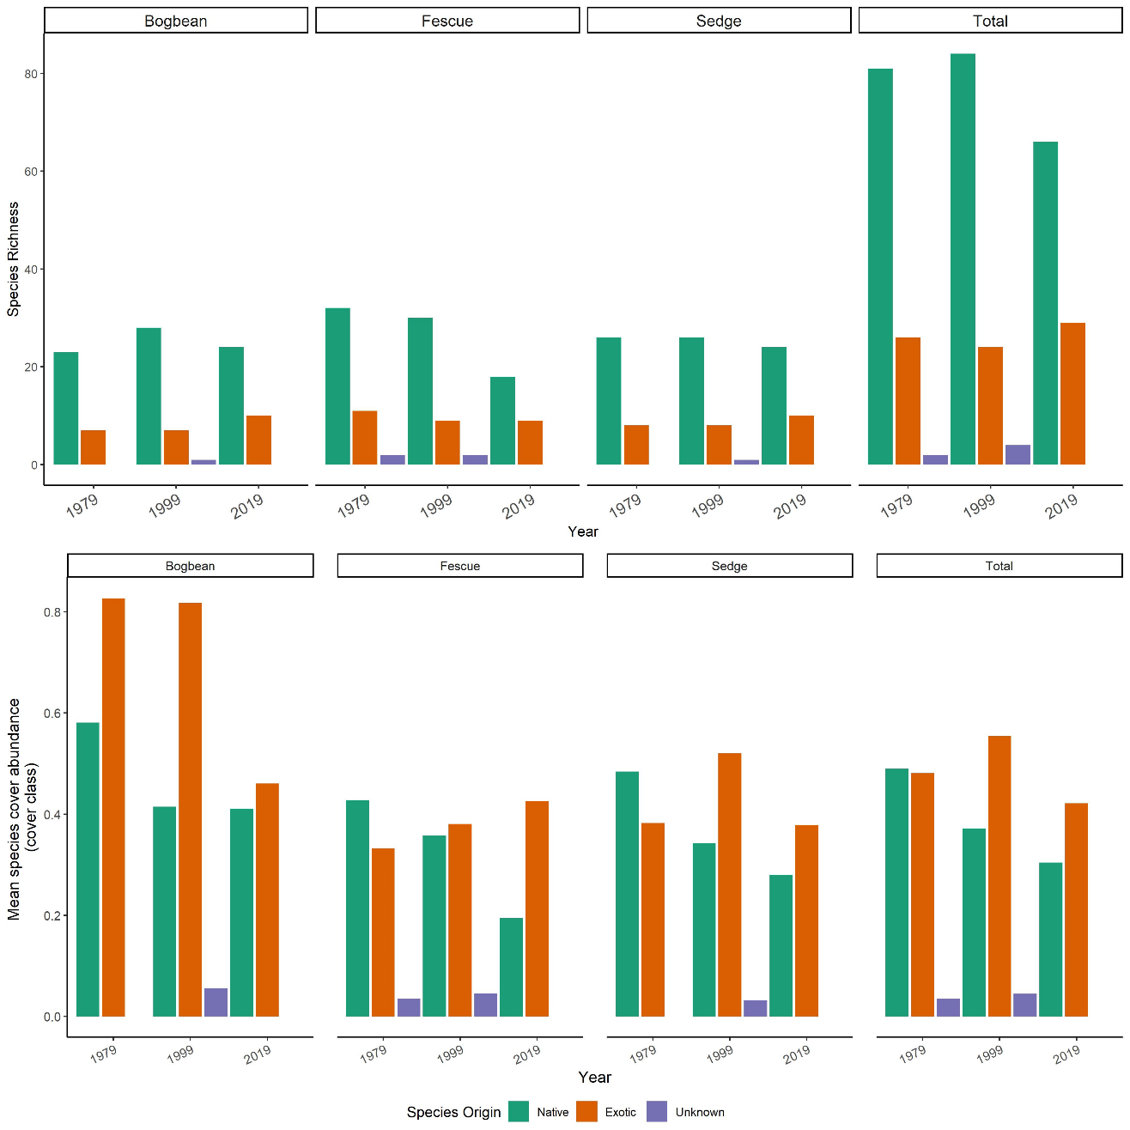

Figure . Top panel: Loss of native species richness over time across all assemblages is largely driven by loss of native species from the Fescue Assemblage. However, native species richness does not change substantially in the other two assemblages. Bottom panel: Native species cover is decreasing on average across all assemblages. Exotic species cover largely remains unchanged, although the ratio of native to exotic cover in Bogbean assemblage becomes more even by 2019. ‘Unknown’ species origin represents species identified only to genus, and assessment of native status cannot be made.

Table . All species recorded in 1979, 1999, and 2019, their synonymous nomenclature, and endemic status according to the United States Department of Agriculture Natural Resources Conservation Service PLANTS Database.

|  |  |  |
| --- | --- | --- |
| **Species found 1979-2019** | **Synonym recorded in 1979, 1999** | **Endemism Status** |
| *Agrostis stolonifera* | *Agrostis alba* | Exotic |
| *Alisma plantago-aquatica* |  | Exotic |
| *Alopecurus geniculatus* |  | Exotic |
| *Bidens cernua* |  | Native |
| *Caltha palustris* |  | Native |
| *Carex lyngbyei* |  | Native |
| *Carex* sp1 |  | NA |
| *Carex* sp2 |  | NA |
| *Cirsium arvense* |  | Exotic |
| *Composite* (unidentified) |  | NA |
| *Deschampsia caespitosa* |  | Native |
| *Dulichium arundinaceum* |  | Native |
| *Eleocharis palustris* |  | Native |
| *Equisetum arvense* |  | Native |
| *Equisetum fluviatile* |  | Native |
| *Equisetum variegatum* |  | Native |
| *Festuca arundinaceae* |  | Exotic |
| *Festuca* sp |  | NA |
| *Galium palustre* |  | Native |
| *Galium* sp |  | NA |
| *Galium trifidum* | *Galium cymosum* | Native |
| Grass(unidentified) |  | NA |
| *Hordeum brachyantherum* |  | Native |
| *Hypericum scouleri* | *Hypericum formosum* | Native |
| *Impatiens capensis* |  | Exotic |
| *Iris pseudacorus* |  | Exotic |
| *Juncus acuminatus* |  | Native |
| *Juncus articulatus* |  | Native |
| *Juncus effusus* |  | Native |
| *Juncus oxymeris* |  | Native |
| *Lathyrus palustris* |  | Native |
| *Leersia oryzoides* |  | Native |
| *Lilaea scilloides* |  | Native |
| *Llilaeopsis occidentalis* |  | Native |
| *Lycopus europaeus* |  | Exotic |
| *Lysichiton americanus* |  | Native |
| *Lysimachia thyrsiflora* |  | Native |
| *Lythrum salicaria* |  | Exotic |
| *Mentha aquatica* | *Mentha citrata* | Exotic |
| *Mentha arvensis* |  | Exotic |
| *Menyanthes trifoliata* |  | Native |
| *Mimulus guttatus* |  | Native |
| *Myosotis scorpioides* |  | Exotic |
| *Myrica gale* |  | Native |
| *Oenanthe sarmentosa* |  | Native |
| *Phalaris arundinacea* |  | Exotic |
| *Platanthera dilatata var dilatata* |  | Native |
| *Poa palustris* |  | Native |
| *Poa trivialis* |  | Exotic |
| *Polygonum hydropiper* |  | Exotic |
| *Potentilla pacifica* |  | Native |
| *Puccinellia pauciflora* |  | Native |
| *Rumex conglomeratus* |  | Exotic |
| *Rumex occidentalis* |  | Native |
| *Sagittaria latifolia* |  | Native |
| *Salix lasiandra* |  | Native |
| *Salix scouleriana* |  | Native |
| *Salix sitchensis* |  | Native |
| *Salix* sp |  | NA |
| *Schoenoplectus tabernaemontani* | *Scirpus validus* | Native |
| *Scirpus microcarpus* |  | Native |
| *Sidalcea hendersonii* |  | Native |
| *Sium suave* |  | Native |
| *Sonchus arvensis* |  | Exotic |
| *Symphotrichum subspicatum* | *Aster eatonii* | Native |
| *Trifolium wormskioldii* | *Trifolium wormskjoldii* | Native |
| *Typha latifolia* |  | Native |
| *Zannichellia palustris* |  | Native |

# Potential journals

## [Wetlands](https://www.springer.com/journal/13157/submission-guidelines#Instructions%20for%20Authors_Article%20Types)

2020 SJR IF 2.369 (Q2, Ecology)

Original research: Articles reporting original research about wetlands, natural or constructed, including, but not limited to mechanisms underlying ecosystem processes, the values of wetlands to society, their management, **quality assessment** and restoration.

## [Marine & Freshwater Research](https://www.publish.csiro.au/mf/forauthors)

2020 SJR IF 2.034 (Q2, Aquatic Science)

Marine and Freshwater Research welcomes the submission of articles presenting original and significant research in the aquatic sciences (see [Scope](http://www.publish.csiro.au/nid/126/aid/429.htm)).

Articles that address broad conceptual questions, are interdisciplinary and of wide interest, and that consider further implications and management applications are especially encouraged, given the journal's broad scope. Specialist articles at the forefront of their field are also welcome as long as their context is clearly stated. **Descriptive articles may be considered if they are placed in an appropriate conceptual setting and have global relevance.** However, articles that are purely taxonomic, parochial, describe preliminary or incremental results, or simply present data without context will not be considered.